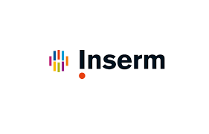

Photograph
5cmx4cm
Researcher Exchange Program

(Exploratory visits)

APPLICATION FORM

Call for applications 2021 for mobility in 2022
Opening date (Inserm side): May 17, 2021 – Closing date: July 28, 2021

Visiting scientist:

1. Full name:
 | family |  | first | middle
2. Date and place of birth:
 | day |  | month | year
 | Place of birth
3. Nationality:
4. Contact address: | Post
 | Tel
 | Email
5. Current appointment: | Institution
 | Department
 | Position
6. Educational background (academic degree: title, year and institution):
7. Professional background:
8. Main scientific publications in the last five years (the five most relevant)*:
9. Knowledge of foreign languages: |  |  | English | French
 | Speaking
 | Reading
 | Writing
Visiting plan:

10. Scientific purpose of the proposed research visit:
11. Duration of the foreseen visit: | From |  |  |  | Proposed date of arrival
 | To |  |  |  | Proposed date of departure
12. Areas you are interested in (to be explained in few words to help establishing the most appropriate visiting program): | Research topics
 | Expertise, know-how (including technical ones)
 | Other areas of interest
13. Institutions, platforms, research facilities and scientists you desire to visit, if already identified: | Institution(s), platform(s), research facilitie(s) (name, place) |  |  | Host scientist(s) (name, tel, e-mail) |  | Period of stay
 |  |  |  |  |  | days
 |  |  |  |  |  | days
 |  |  |  |  |  | days
 |  |  |  |  |  | days
 |  |  |  |  |  | days
14. Other suggestions:

Other items:

15. Other general comments or information you would like to add:

